

Lab 16: Implement resource tagging

At the end of each lab, any resources you created in your account will be preserved. Some Azure resources, such as VM instances, may be automatically shut down, while other resources, such as storage services will be left running. Keep in mind that some Azure features cannot be stopped and can still incur charges (i.e. Azure Bastion). To minimize your costs, delete all resources and recreate them as needed to test your work during a session.

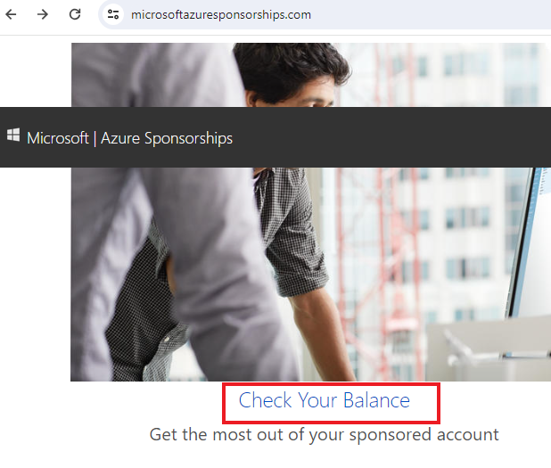

Reference: [AZ-900T0X-MICROSOFTAZUREFUNDAMENTALS](https://microsoftlearning.github.io/AZ-900T0x-MicrosoftAzureFundamentals)

# 16 - Implement resource tagging

In this walkthrough, we will create a policy assignment that requires tagging, created a storage account and test the tagging, view resources with a specified tag, and remove the tagging policy.

# Task 1: Create a resource group (5 min)

In this task, we will create a resource group for this exercise.

1. Sign in to the [Azure portal](https://portal.azure.com/) with your **odl_user_xxx** azure account
2. From the **All services** blade, search for and select **Resource groups**, then select **+ Create**.
3. Create a new resource group. When you are done click **Review + create** and then **Create**.

| Setting | Value |
| --- | --- |
| Subscription | **Use your subscription (you should see “Seneca College : <course name>”)** |
| Name | **<studentid>RGTags (example: sm548RGTag)** |
| Region | **(US) East US** |

# Task 2: Assign the required permission of your CloudLab Account (5 min)

In this task, we will add the required permission to allow you to assign a policy to the new resource group.

1. Go to the Resource Group that you created in the above task and select **Access Control (IAM)**
2. From the **Access Control (IAM)**, select **Add** and **Add role assignment,** search for **Resource Policy Contributor,** then click **Next**

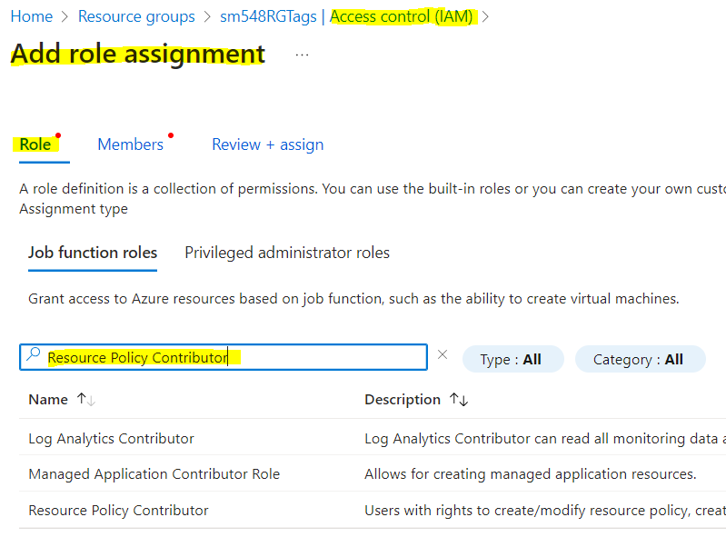

1. Select the second tab (**Members**) and select “**+Select Member**”.
2. Search for **your** CloudLab account (ie. **odl_user_xxx@xxxxx**), click **Select**

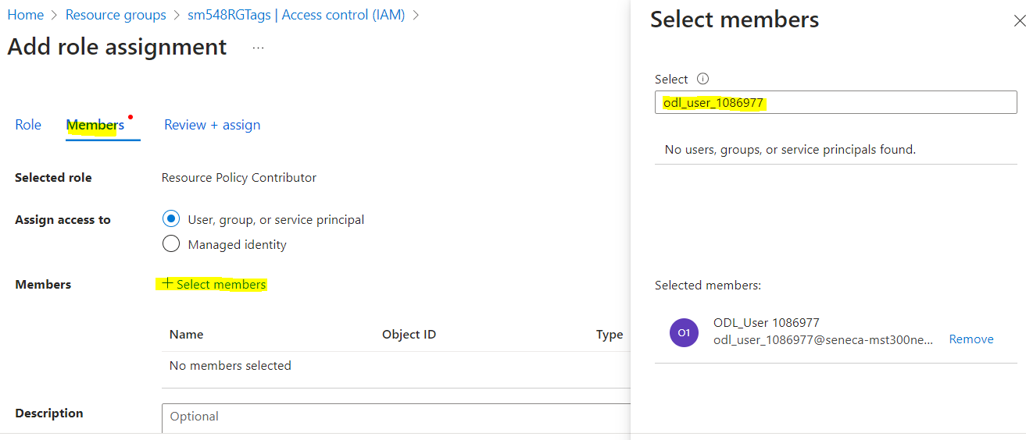

1. When you are done click **Review + assign**.
2. Now your CloudLab account has the required access to assign a policy to your new resource group from Task 1
3. Important: It may take 5-10 minutes for the new permission to be enabled.

# Task 3: Create a Policy assignment (5 min)

In this task, we will configure the **Require a tag on resources** policy and assign it to our subscription.

1. From the **All services** blade, search for and select **Policy**.
2. Scroll down to the **Authoring** section, click **Assignments**, and then click **Assign Policy** from the top of the page.
3. Notice the **Scope** for our policy will be subscription wide. Make sure to select the new Resource Group that you created in Task 1

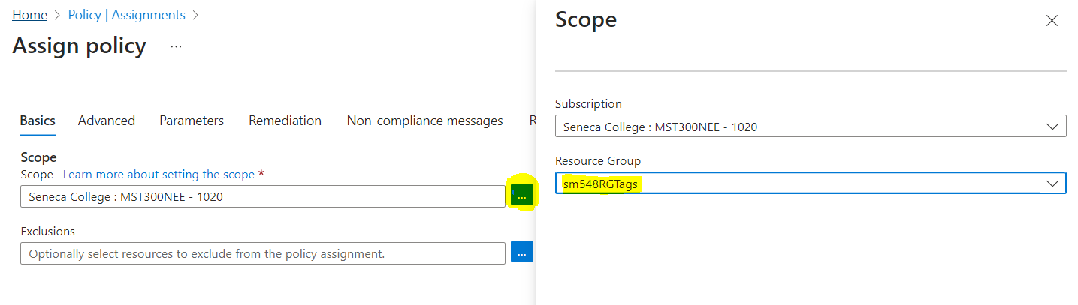

1. Select the **Policy definition** ellipsis button (end of the textbox on the right). **Search** for policy definitions including the value **tag**, in the result set, click on the **Require a tag on resources** definition, then click **Add**.

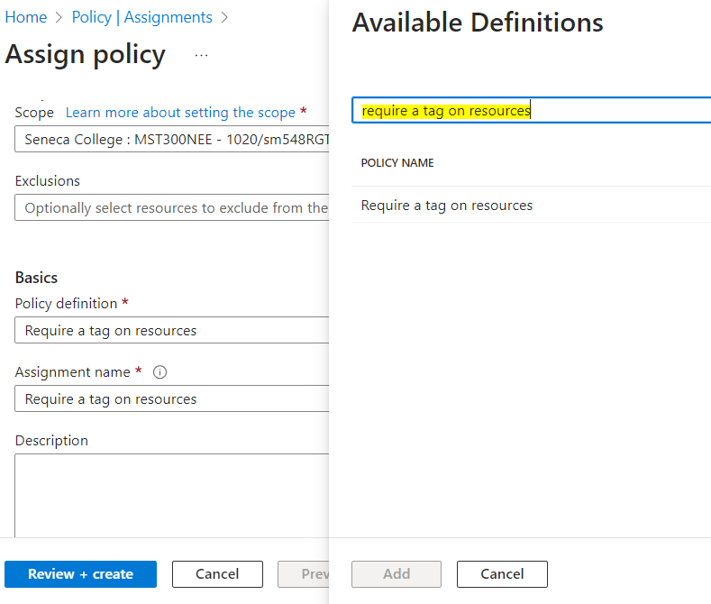

1. On the **Assign policy** blade, in the **Parameters** tab, type in **company** for the **Tag Name**. Click **Review + create**, and then **Create**.

**Note:** This is a simple example to demonstrate tagging. Please note that the assignment takes around 30 minutes to take effect.

1. The **Require a tag on resources** policy assignment is now in place. When a resource is created, it must include a tag with the Company key.

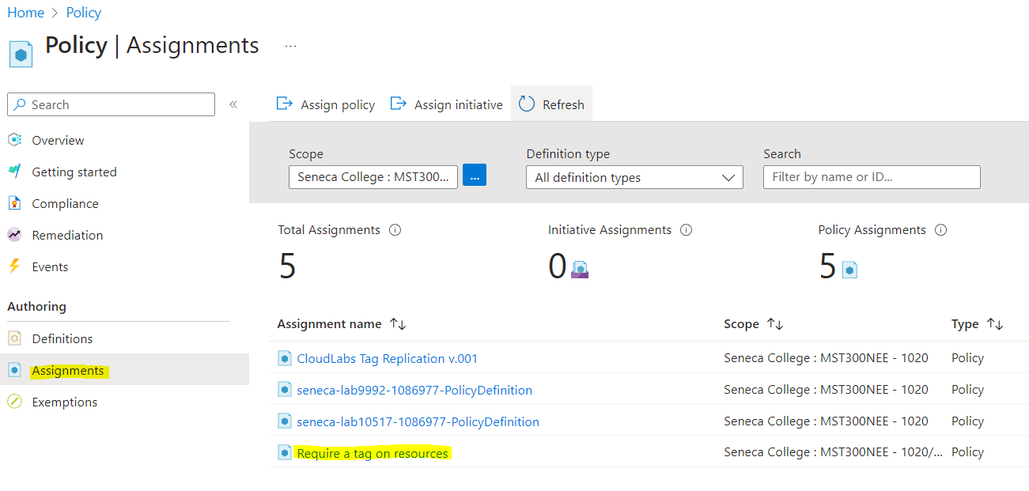

# Task 4: Create a storage account to test the required tagging

In this task, we will create storage accounts to test the required tagging.

1. In the Azure Portal, from the **All services** blade, search for and select **Storage accounts**, and then click **+ Create**.
2. On the **Basics** tab of the **Create storage account** blade, fill in the following information (replace **xxxx** in the name of the storage account with letters and digits such that the name is globally unique). Leave the defaults for everything else.

| Setting | Value |
| --- | --- |
| Subscription | **Use your subscription (you should see “Seneca College : <course name>”)** |
| Resource group | **<Select the Resource Group that you created in Task 1>** |
| Storage account name | **<studentID>storageaccountxxxx (example: smore1storageaccount)** |
| Location | **(US) East US** |
| Redundacy | **Locally-redundant storage (LRS)** |

1. Click **Review**.

**Note:** We are testing to see what happens when the tag is not supplied.

1. You will receive a Validation failed message. Click the **Click here to view details** message. On the **Errors** blade, on the **Summary** tab note the error message stating that resource was disallowed by Policy.

**Note:** If you view the Raw Error tab you will see the specific tag name that is required.

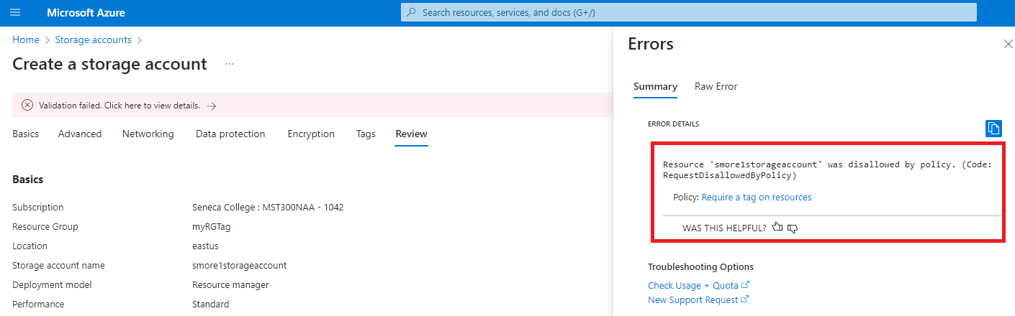

1. Close the **Error** pane and click **Previous** (bottom of the screen). Provide the tagging information.

| Setting | Value |
| --- | --- |
| Tag name | **Company** (may not be in the drop-down list) |
| Tag value | **Contoso** |
|  |  |

1. Click **Review + create** and verify that the validation was successful. Click **Create** to deploy the storage account.

# Task 5: View all resources with a specific tag

1. In the Azure Portal, from the **All services** blade, search for and select **Tags**.
2. Note all tags and their values. Click the **Company : Contoso** key/value pair. This will display a blade showing the newly created storage account, as long as you included the tag during its deployment.

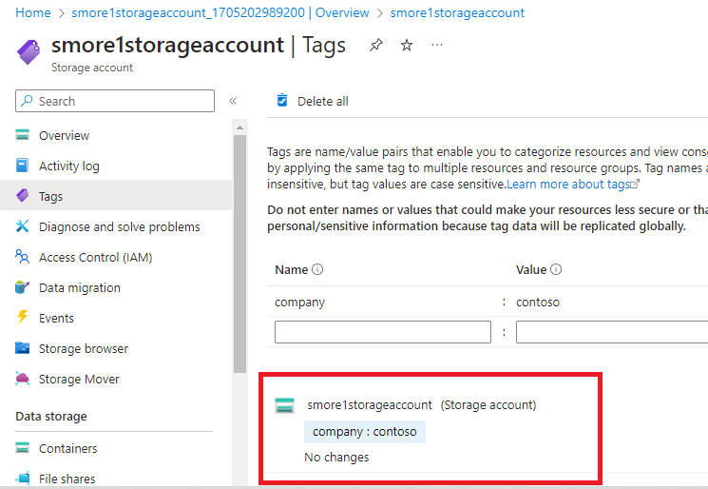

1. In the Portal, display the **All resources** blade.
2. Click **Add filter** and add the **Company** tag key as the filter category. With the filter applied, only your storage account will be listed.

[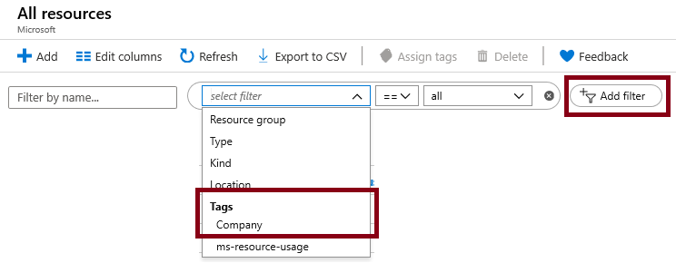](https://microsoftlearning.github.io/AZ-900T0x-MicrosoftAzureFundamentals/Instructions/images/1706.png)

# Task 6: Delete the policy assignment

In this task, we will remove the **Require a tag on resources** policy so it does not affect our future work.

1. In the portal, from the **All services** blade, search for and select **Policy**.
2. Click the **Require a tag on resources** policy entry.
3. Click **Delete Assignment** in the top menu.
4. Confirm you wish to delete the policy assignment in the **Delete assignment** dialogue by clicking **Yes**
5. If you have time, create another resource without a tag to ensure the policy is no longer in effect.

In this walkthrough, we created a policy assignment that required tagging, created a storage account and tested the tagging, viewed resources with a specified tag, and removed the tagging policy.

**Note**: To avoid additional costs, you can remove all resources in the resource group. Search for resource groups, click your resource group, and then delete the resources within the resource group. **DO NOT DELETE YOUR RESOURCE GROUP.**

# Submission Requirements

Submit a screenshot with the following information:

**Screenshot #1:**

* Error message when attempting to create a storage account without the correct tags
* The Azure Portal with your **CloudLab Account** [requires another browser window]
  + **Note**: underline the above items as described in the below picture

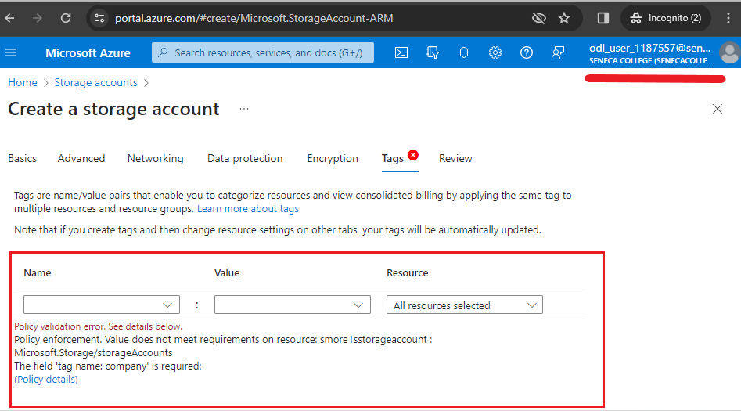

**Screenshot #2:**

* Successful deletion of all resources within resource group. **DO NOT DELETE YOUR RESOURCE GROUP!**
  + To delete all resources with a resource group, go to “**Resource Group**”, select “**<studentid>RGTags**”, select all resources within the resource group, and select “**Delete**”

